Recap of JavaScript:
Functions in JavaScript:
Function is a block in which we can add a set of instructions/statement to do particular task or action.
Simple: A function is a set of statements grouped together to perform a specific task.
It helps in modularity, reusability, and clean coding practices.
Why Use Functions?
- To reuse logic in multiple places without rewriting code.
- To improve code readability and maintainability.
- To encapsulate logic (especially business logic) within components.
Named Function, anonymous function and Arrow function etc.
Difference between Arrow and Normal and Function Expression.
Arrow Function
- Short syntax, good for callbacks.
- Inherits this from the outer scope (lexical this).
- Cannot be used with new or as a constructor.
- Not hoisted.
const arrow = () => {
console.log("This is an arrow function");
};
Normal Function (Function Declaration)
- Has its own this context.
- Can be hoisted (called before it's defined).
- Can be used for constructors (with new).
function namedFunction() {
console.log("This is a normal function");
}
Function Expression
- A function without a name(anonymous function), assigned to a variable.
- Can be either normal or arrow.
- Not hoisted.
const anonymousFunction = function () {
console.log("This is a function expression");
};
Callback functions.
A callback is a function passed as an argument to another function, which will be called (executed) later inside that function.
Why Use Callbacks?
- To handle asynchronous operations (like APIs, timers, file reads).
- To execute code after a task is done.
- To keep your code non-blocking (especially in Node.js).
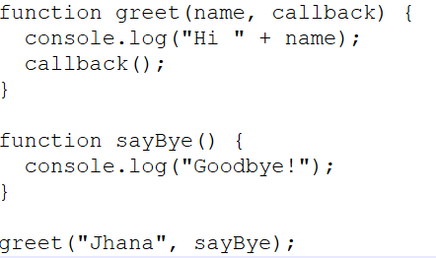
What is Callback Hell?
Callback Hell refers to a situation where multiple nested callbacks make the code hard to read, maintain, and debug.
It usually happens when asynchronous operations depend on one another and are nested deeply.
In order to overcome from callback hell we can go with Promises or async/await to improve readability, reduce nesting, and handle errors better.
Promises?
It is a special object in JavaScript that represents the eventual completion or failure of an asynchronous operation and its resulting value.
It provides a cleaner alternative to callback hell and improves readability and maintainability of asynchronous code.
Senario:
Output of function1 → passed to function2 with the help of promise
Output of function2 → passed to function3 with the help of promise
We can create promise Using new Promise() constructor
var promise = new Promise()
Promise() constructor takes one callback function as a argument with predefined functions--<resolve, reject>
The predefined function will store data in the promise.
var promise = new Promise(function(resolve, reject) { });
Basic Promise Creation
var promise = new Promise(function(resolve, reject) {});
console.log(promise); // Prints: Promise {<pending>}
A Promise is a placeholder for a future value.
At this point, it’s in pending state because:
Neither resolve() nor reject() was called.
Self-referencing Inside a Promise
var promise1 = new Promise(function(resolve, reject) {
console.log('promise1', promise1);
// ReferenceError or undefined--promise1 is still being declared and has not been initialized
resolve(1234);
});
If you store data inside the promise using resolve() then that is called success data.
If you store data inside the promise using reject() then that is called failure data.
Multiple resolve() Calls
var promise1 = new Promise(function(resolve, reject) {
resolve(1234); // This works ✅
resolve("pass"); // ❌ Ignored
resolve({ name: "jhana", city: "chennai" }); // ❌ Ignored
});
A Promise can be settled only once — either resolved or rejected.
How to access data from Promises?
1.Using .then() and .catch().
2.async and await with try catch block
Using .then() and .catch()
promiseObj
.then(function(successdata){})
.catch(function(errordata){})
.then(function(successdata){}): runs if the promise resolves successfully; successdata is the value passed to resolve().
.catch(function(errordata){}): runs if the promise is rejected; errorData is the value passed to reject().
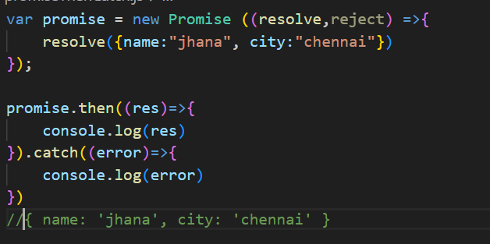
async and await with try catch block
async/await is syntactic sugar over Promises. It allows us to write asynchronous code that looks and behaves more like synchronous code. This improves code readability, avoids .then() chaining, and handles errors using try/catch blocks — making async flows easier to manage, especially in Express routes or data-fetching scenarios.
Event loop, single-threaded model
CommonJS vs ES6 modules
Built-in modules: fs, path, http, events, etc.
Package.json
Local vs global modules
Creating a Web Server (using http module)

In js file.
- Have to import express const express = require('express');
We can import as import import express from "express"; If used “type”:module
- Instance of express need to store in variable. const app = express();
- Define a route in order to access API usig url.
app.get('/', (req, res)=>{
res.send(“hello World”)
})

const port = 3000;

app.listen(port, () => {

console.log(“server is listening”,+ port);

})

In terminal run : node server.js ------(node js file name)
(npx kill port === to kill port)

//CREATING A TODO LIST
Let todos =[];

app.post('/todos',(req,res)=>{
const {title, description} = res.body;---(where the output from API from todos url)
const newTodo ={// newTodo—storing of API values from todos
id : 0,
title,
description
};
todos.push(newTodo);pushing values to todos from newTodo
console.log(todos);//logging it
res.status(201).json(newTodo);// sending newTodo values JSON format

})

It is framework for NODE JS
npm install express.- package-lock.json will create
In package.json- under dependencies express will be available.
import express from "express"; so that we can use express JS in node.JS
const app = express();-express() module calling as function. (Instance of express)

(OR)
const express = require('express');
const app = express();

MONGO DB
MongoDB Integration
Using mongoose with Expres

No sql is a type of data base designed to store, manage and retrieve data without structural format.
It allows for flexible schemas, scalability, and high performance, making it suitable for large-scale applications and real time applications.
Handle key-pair values, graphs and wide columns.
Mongo DB is a no sql DB that uses a flexible, document-oriented data model to store data in JSON like BSON format.
It allows dynamic schemas, large volume of data across distributed system.
JSON: JavaScript object notation is a light weight data interchange.
It is a simple format to represent structured data object, array and key-pair value.
BSON: Binary encoded serialization format that extends JSON like adding data type likes integer, and dates making it more efficient for storing and retrieval.
It is primary data format used by mongo DB for storing documents and making procedure calls.
INTEGRATION OF MONGODB
npm install mongoose
const mongoose = require('mongoose');

mongoose.connect('mongodb://localhost:27017/mern-app')
.then(()=>{
console.log('DB connected')
})
.catch((err)=>{
console.log(err);
})

Connecting to MongoDB Server
Step 1: Open command prompt(cmd) in your system
Step 2: Type 'mongosh' then hit enter key
Show database
show dbs: It will show all the available databases

Command to connect database
#Syntax: use [database name]: It will pick you which data base need to work on

How to delete collection:
db.collectionname.drop() ex: db.orders.drop()

CRUD Operation
- Create
  - insertOne(data,options)
  - insertMany(data,options)
Creating Collection & Document
#Syntax: db.collectionName.insertOne({document})

#Example db.products.insertOne({name:'Mac Book Pro',price:120000,brand:'Apple'})
Under the database need to create a collection in that we have to inserted one document.

Example: db.products.insertMany([{name:'Iphone14',price:75000,brand:'Apple'},{name:'Samsung Galaxy A50',price:54000,brand:'Samsung'}])
Under the database need to create a collection in that we have to insert more than one document.

- Read
  - find(filter,options)
  - findOne(filter,options) #first matching document
To get all the data from the collection
#Syntax: db.collectionName.find(): It will show us the document available in that particular collection(1st set)

db.customers.find().toArray():All data
db.customers.find().forEach((customersData)=> {printjson(customersData)})
db.products.find().forEach((customersData)=> {printjson(customersData)})

db.products.find({},{name:1,price:1}) :it will list only name and price along with id

db.products.find({},{_id:0,name:1,price:1}) :it will list only name and price.

#Syntax: db.collectionName.find({particular document}): It will show us current document available in that particular db

#Syntax: db.collectionName.findOne({particular document}): It will show us first one of the current document available in that particular db
Example:
db.products.find({brand:'Apple'}) :
Example:
db.products.findOne({brand:'Apple'})
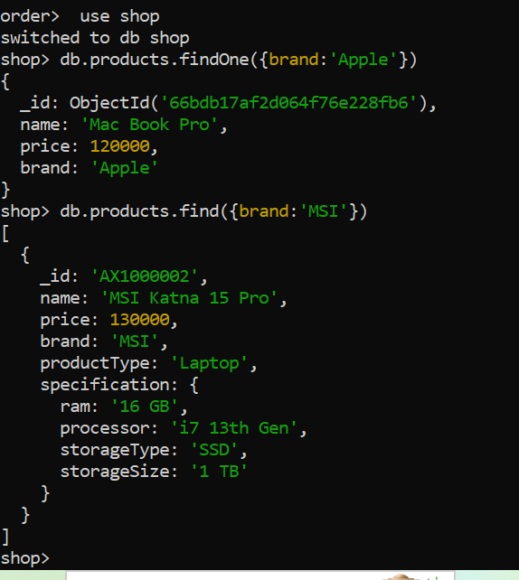
- Update
  - updateOne(filter,data,options)
  - updateMany(filter,data,options)
  - replaceOne(filter,data,options)
Update document in collection
#Syntax: Db.collectionName.updateOne({},{}): filter and what to set

Example:
db.products.updateOne({name:'Mac Book Pro'},{$set:{productType:'Laptop'}})

Example:
db.products.updateOne({name:'Samsung Galaxy s24 Ultra'},{$set:{price:93000}})

Example:

db.products.updateOne({name:'Bravia 43 inch 4k'},{$set:{price:45000}})

Example:

db.products.updateOne({name:'Iphone 15'},{$set:{brand:'Apple',productType:'Mobile'}})

Example:

db.products.updateMany({_id:{$in:[ObjectId('66695c4aa52b865509cdcdf8'),ObjectId('66695c8ba52b865509cdcdfd')]}},{$set:{productType:"Mobile"}})

Example update many
db.products.updateMany({_id:{$in:[ObjectId('66695c4aa52b865509cdcdf8'),ObjectId('66695c8ba52b865509cdcdfd')]}},{$set:{productType:"Mobile"}})

Replacing of entire document:
db.products.replaceOne({_id:ObjectId('66695c8ba52b865509cdcdfc')},{name:"Iphone 14 Pro Max",price:115000,brand:'Apple',productType:'Mobile'})
- Delete
  - deleteOne(filter,options)
  - deleteMany(filter,options)

Delete document from collection
# the following command will delete the 1st document with matched filter
db.products.deleteOne({brand:'Apple'})
# the following command will delete document many at same time
db.products.deleteMany({productType:'Laptop'}) documents matches the filter will delete from collections
db.products.deleteMany({})--- all documents will delete from collections
deleting collection:
db.products.drop()---collection will delete
Deleting Database:
db.dropDatabase()

